Snapshot is a short term backup of vm’s OS and Data disk
Its is used in the case of faster recovery
Its used in scenarios where you take ss before application Upgrade , patching or want to try some experiment in the environment

Vm capture – it will create a template by which you can create more vms within less time
Requirement ;
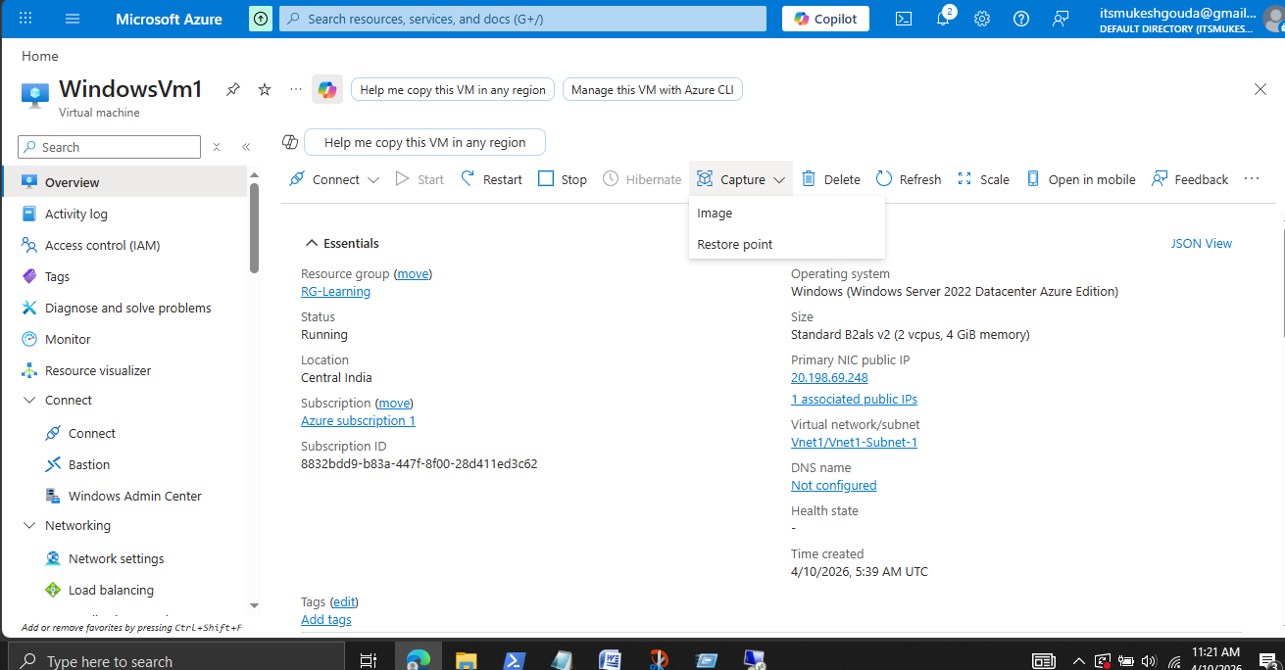
Check system version - ver
To make Vm ready for Template use inside the VM – sysprep
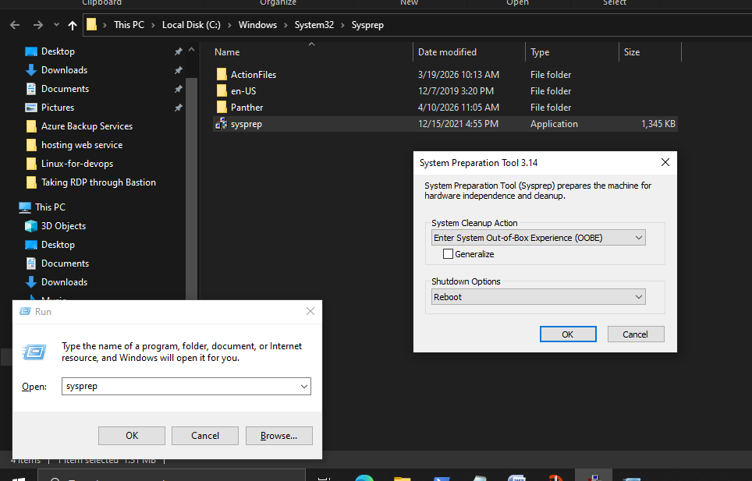

Select generalized and choose shutdown
- It will show the vm status in azure portal as shutdown and its ready to be captured .
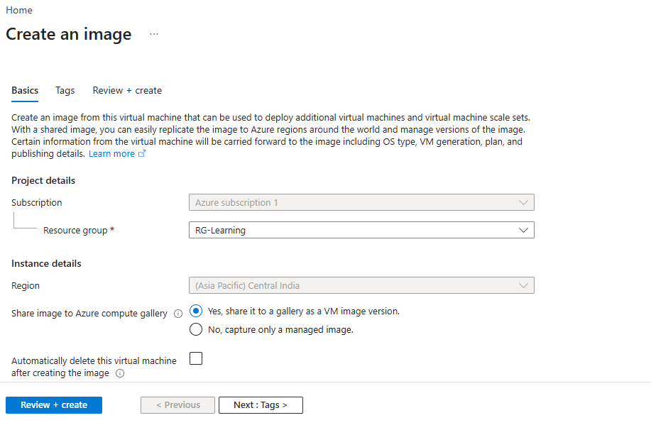
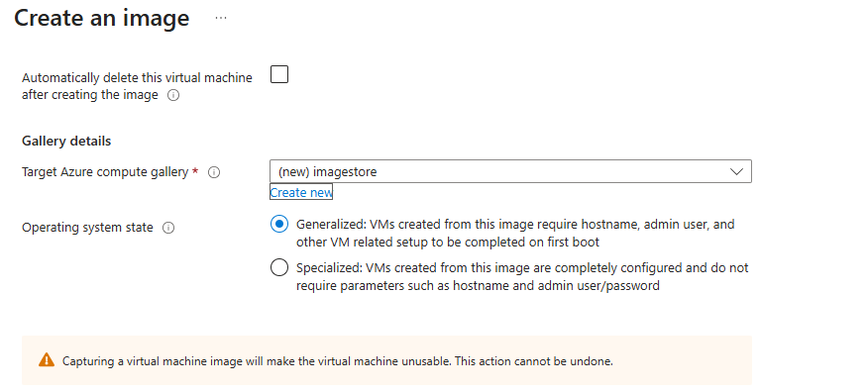
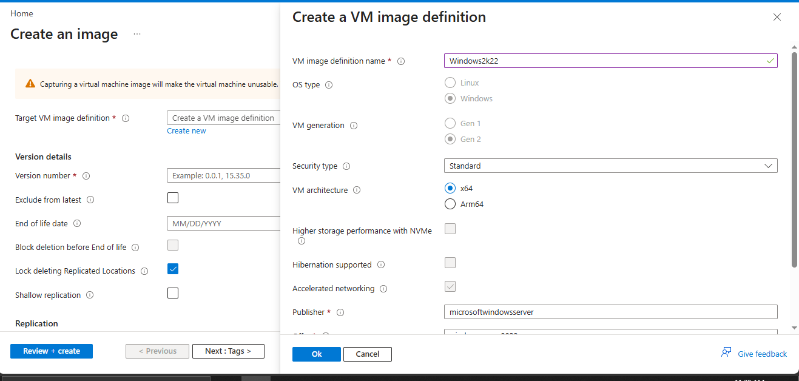
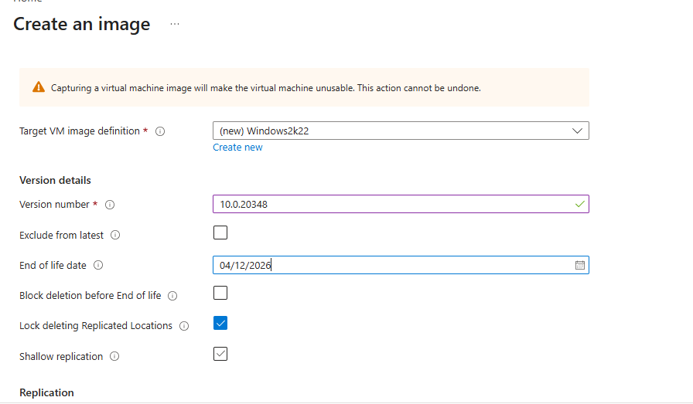

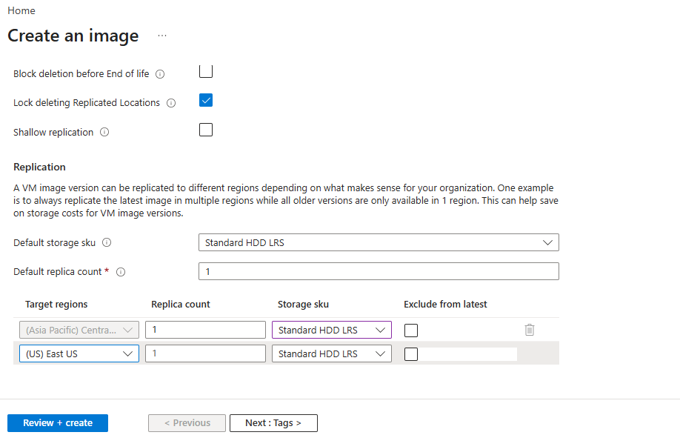
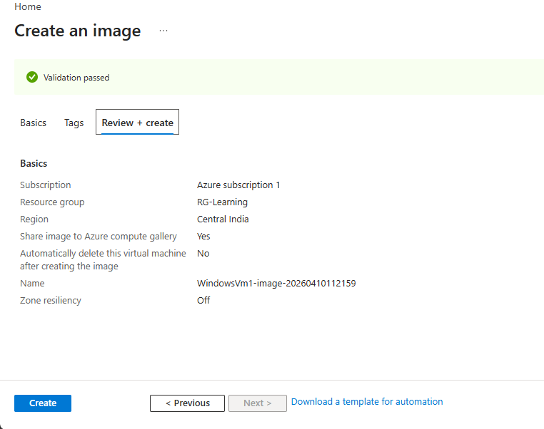
After template creation we you cannot start the VM from which you had created the Template /Image .

Now go to Vm image version , there you can find the template
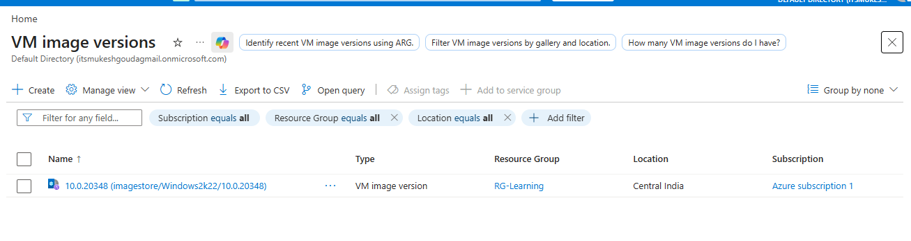

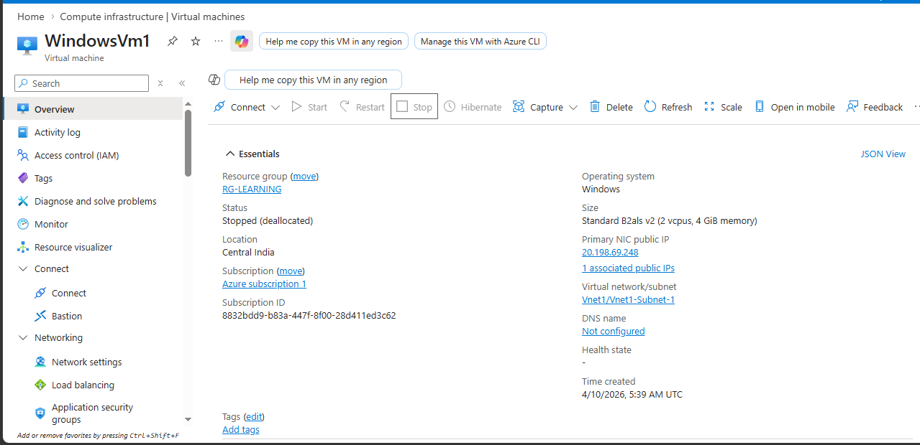

You can create Vms using the template . It will create the same configuration as the template , but you can change the required user name and passwords etc.vm creation process will be same .
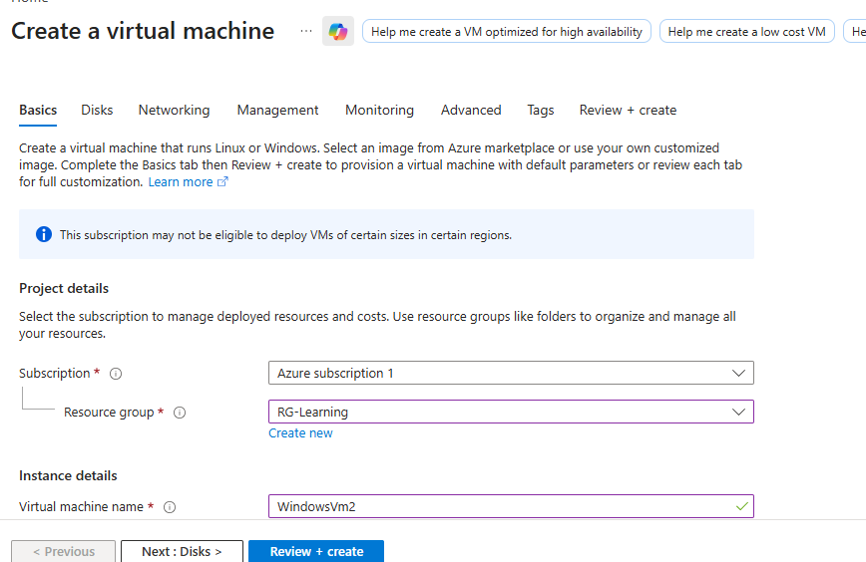
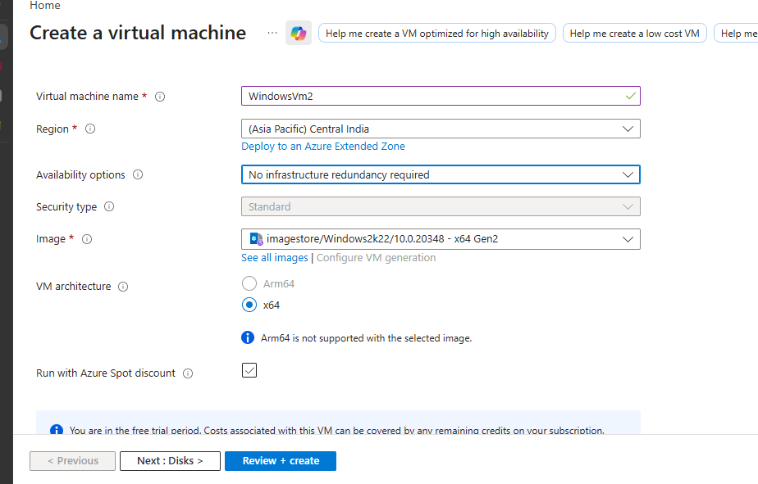
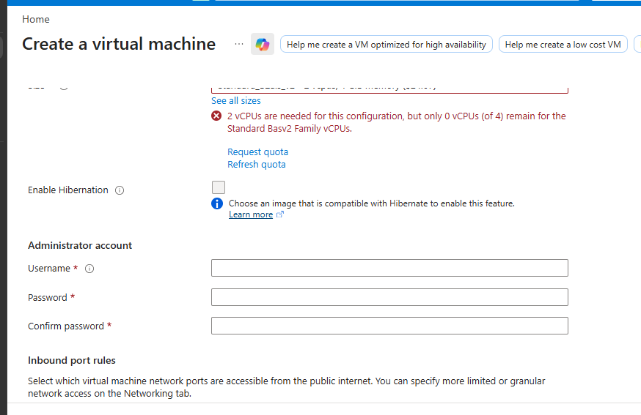

Note it will configured in the same location without any changes . if you do some changes . then it will not allow you to deploy the change.

